Places to get CPR certified:
Please keep in mind your CPR certification must be BLS through American Red Cross or American Heart Association.

Online with required in person skills check off:

Lofton Medical
106 Rolls Royce Drive
Broussard, LA 70518
Phone: 261-3539
Website: www.onlineaha.org (choose Heartcode BLS)

Face to Face Classes:

National EMS Academy
2916 North University Avenue
Lafayette, LA 70507
Phone: (866) 459-3500
Website: www.nationalemsacademy.com

Southwest Safety Training, Inc. 330 Guilbeau Rd.
Lafayette, LA 70506
Phone: (337) 989-0120
E-mail: info@southwestsafetytraining.com Website: www.southwestsafetytraining.com

Safe and Secure Training and Certification
116 Sigma Drive
Your CPR card should look like one of these:
Lafayette, LA 70506
Contact: Debbie Mamerow
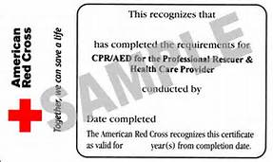
Phone: 337-988-4839
Website: www .sastrainers.com

Toni Lavergne Blanchard
Phone: (337) 288-5462
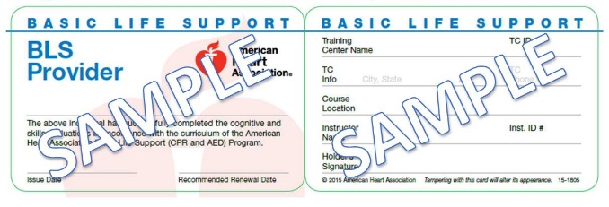
E-mail: tonilavergne@hotmail.com

Melody Seward
Phone: (225) 354-6608
E-mail: CPR.Staying@live.com

